CENWP-OD-TDD December 8, 2020

MEMORANDUM FOR THE RECORD

SUBJECT: 20TDA14 Fish Unit F2 Oil Spill and Response Plan

The east fishway fish units were taken out of service on December 1st in preparation for east fish ladder dewatering on December 2nd. On December 3rd an oil sheen was observed in the tailrace. Shortly afterwards it was determined the source was fish unit F2 thrust tub cooler failure, followed by an oil level annunciation failure. Maximum oil loss estimates were 200 gallons. However further recovery from plumbing lines within the powerhouse will likely decrease that loss estimate.

The oil traveled with the cooling water discharging into the tailrace directly downstream of fish unit F1, west end of the powerhouse, at approximately 10’ depth. F1 is located near entrance to the east fishway. Bulkheads were immediately installed in the entrances in effort to prevent oil from entering the fishway. Recovery efforts were made over the weekend with Bonneville dam spill response team and Clean Harbors contractors. A containment boom was installed between F2 and the west entrance. Five juvenile fish mortalities were collected by crews, however project fisheries determined they were shad. During the process a partial oil sheen was noticed inside the west entrance up the channel to about main unit 2, approximately 200 feet from the entrance. Plans were executed on December 7th to recover oil from within the west entrance area by installing absorbents immediately inside the west entrance, then opening the entrance to allow flow out across the absorbents. Absorbent pads will be inspected on December 9th.

Recovery of the absorbent pad requires project boats to access the west powerhouse. To do this safely, the ice trash sluiceway must be closed during boat operations. Oil recovery operation (removing and replacing the absorbent pads) could be needed several days until all oil and equipment is removed. The amount of closure time will be documented. Proposal for FPOM will be to add this sluiceway operation to the end of the normal season of December 15th.

- Species – None
- Origin – NA
- Length – NA
- Marks and tags – NA
- Marks and Injuries found on carcass – NA
- Cause and Time of Death – NA
- Future and Preventative Measures – To be determined after full investigation

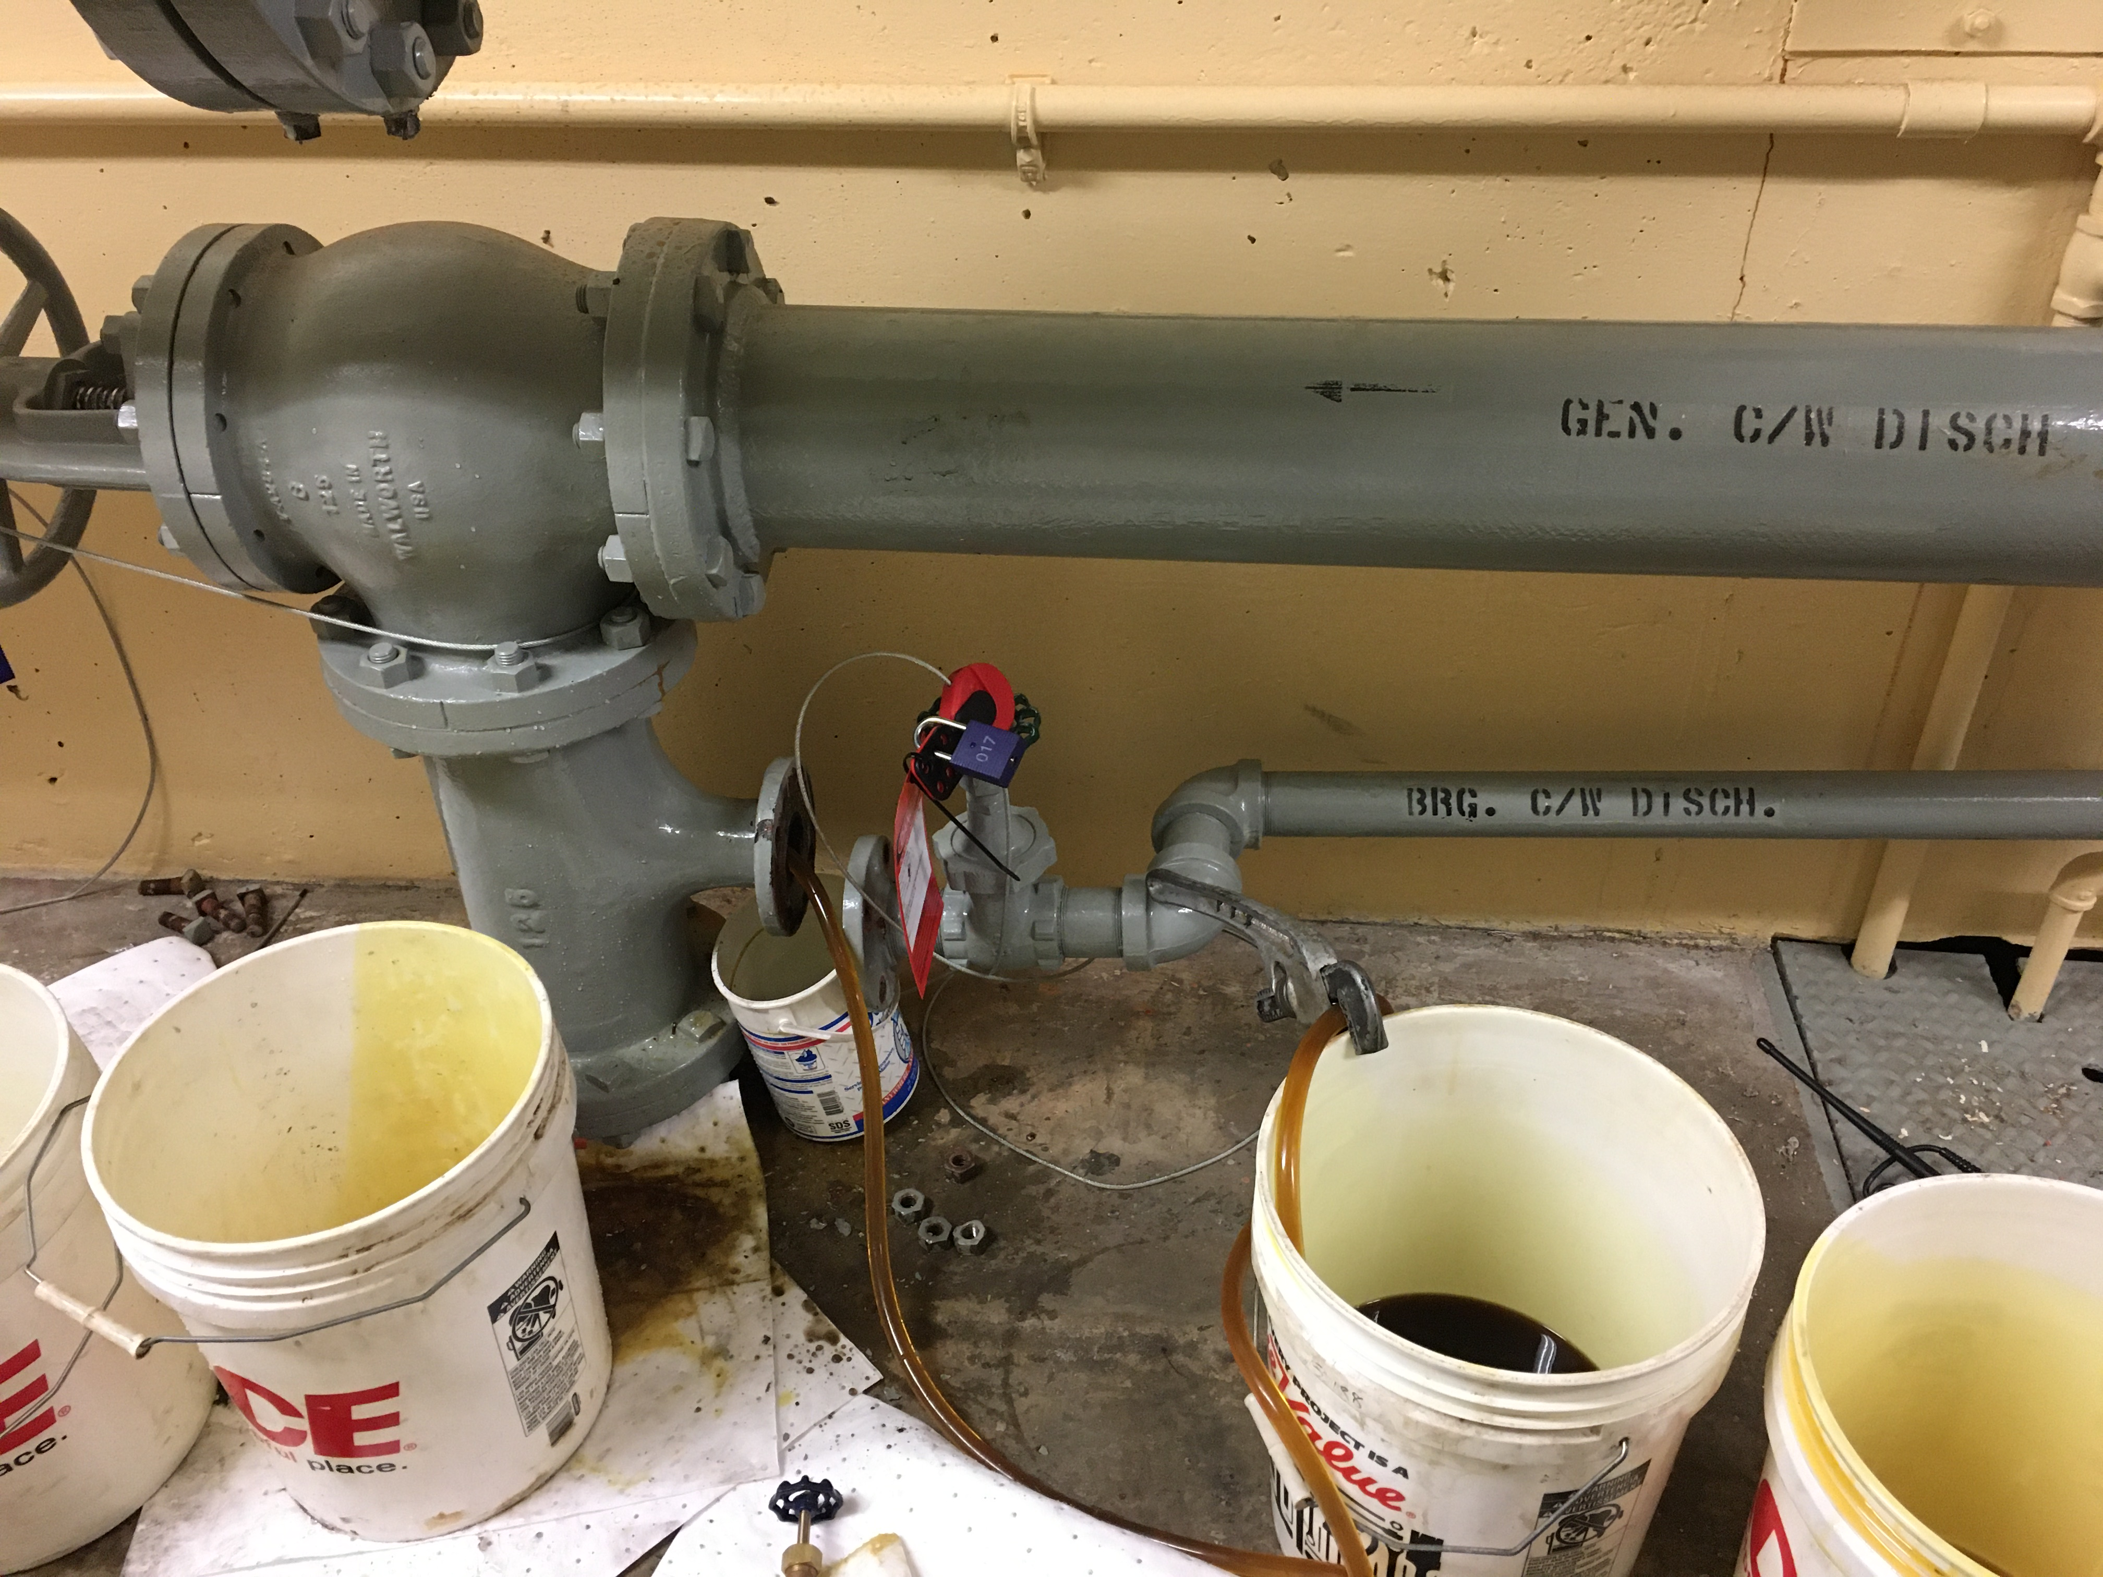
Figure 1. Oil recovery efforts from inside powerhouse.
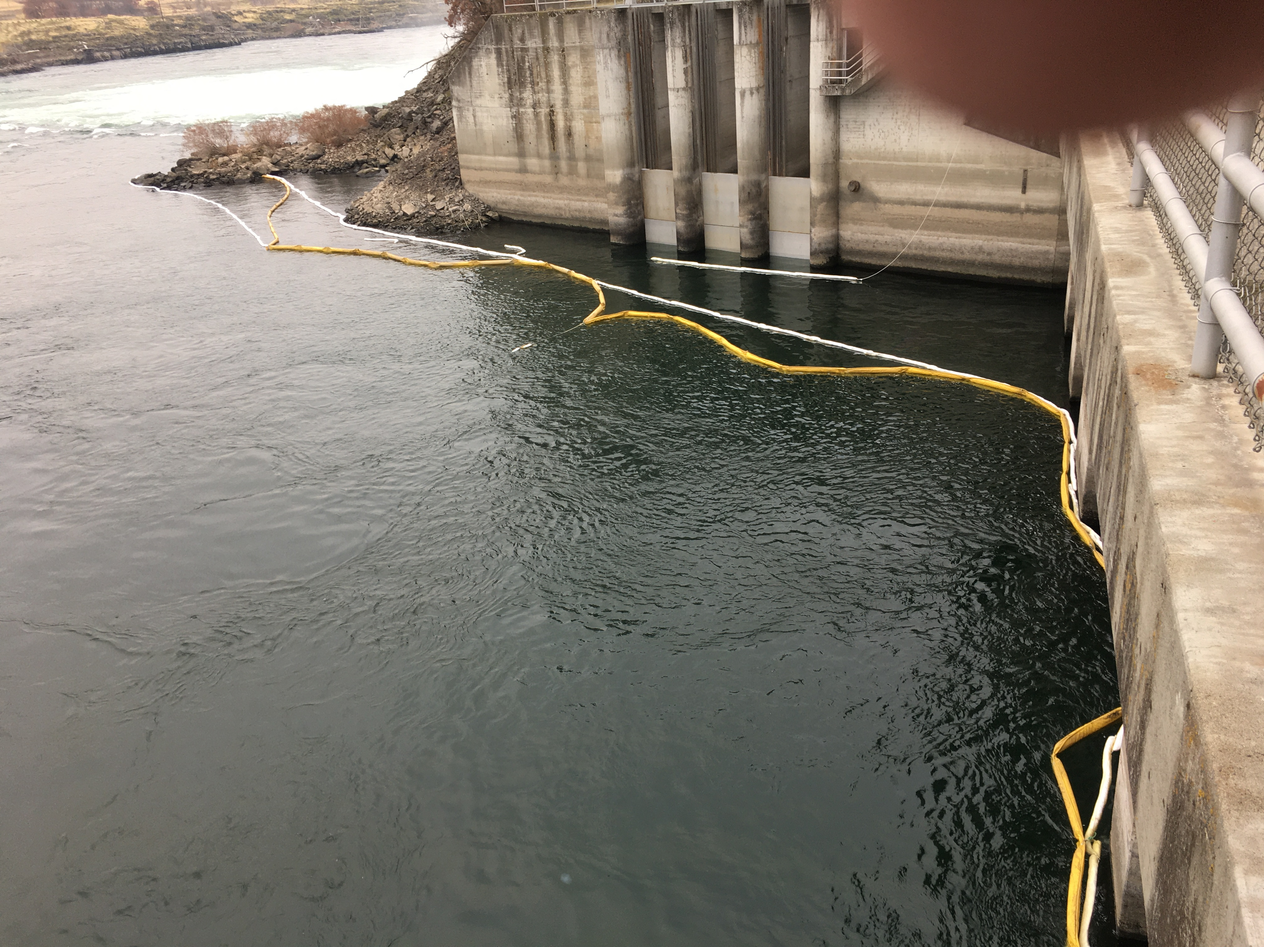
Figure 2. Remaining containment boom at west entrance after 2 days of recovery efforts. Note three bulkheads are in place to seal off the fishway from oil.
Sincerely,
Bob Cordie
Project Fisheries

